**Conduct audit**

**Dealer:** CHOUDHARY TRADERS (0016C004)  
**Managed by :** rahul.lalmohan/lrl

1.Rate the condition of the signage board on appearance, visibility and installation?

Ans. 3/5 , Good

2. Was the store functioning as per operation timings?

Ans. 4/5 Yes,

Opening Time - 11 : 00 AM

Closing Time - 08 : 30 PM

3. How was the store's external cleanliness?

Ans. 4/5 ,Need to improve

4. Were all incoming customers greeted warmly?

Ans.- 4/5 ,Yes all incoming customers are greeted warmly.

5. Was the store clean and organised?

Ans. – 4/5, Need to improve

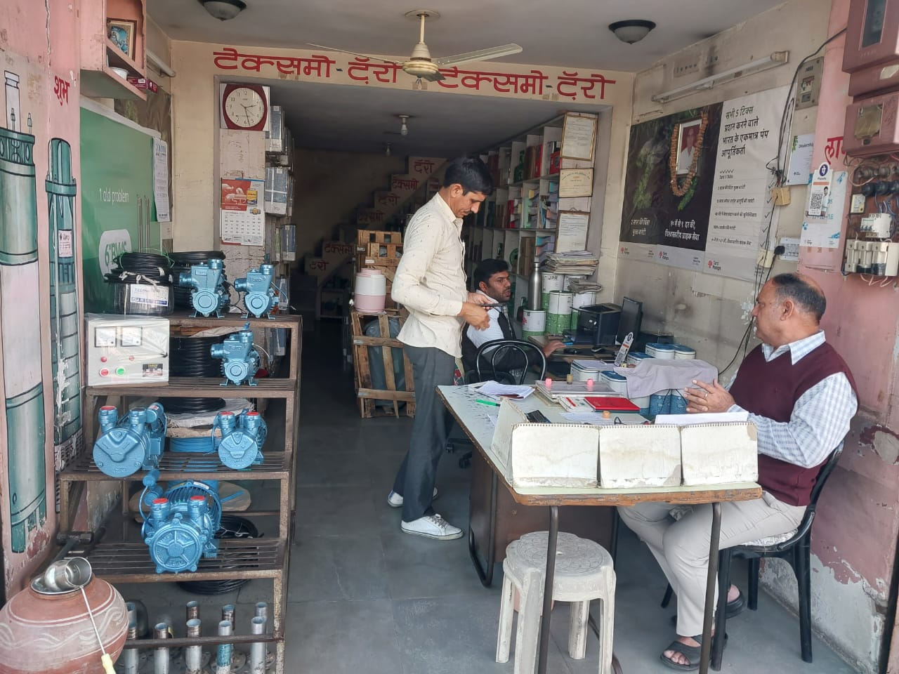

6.Did the store have Taro pumps products on display?

Ans.- 4/5, display is good.

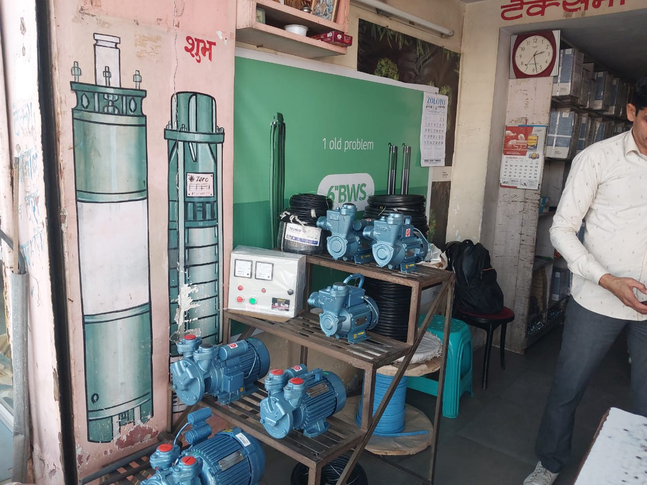

7. Was the store ventilated properly and did the store seem welcoming?

Ans. – Yes, 4/5

8. Was there adequate lighting in the store?

Ans.- Yes,4/5

9. Was the dealer certificate displayed clearly?

Ans. – 4/5 yes, but not as per our standard. 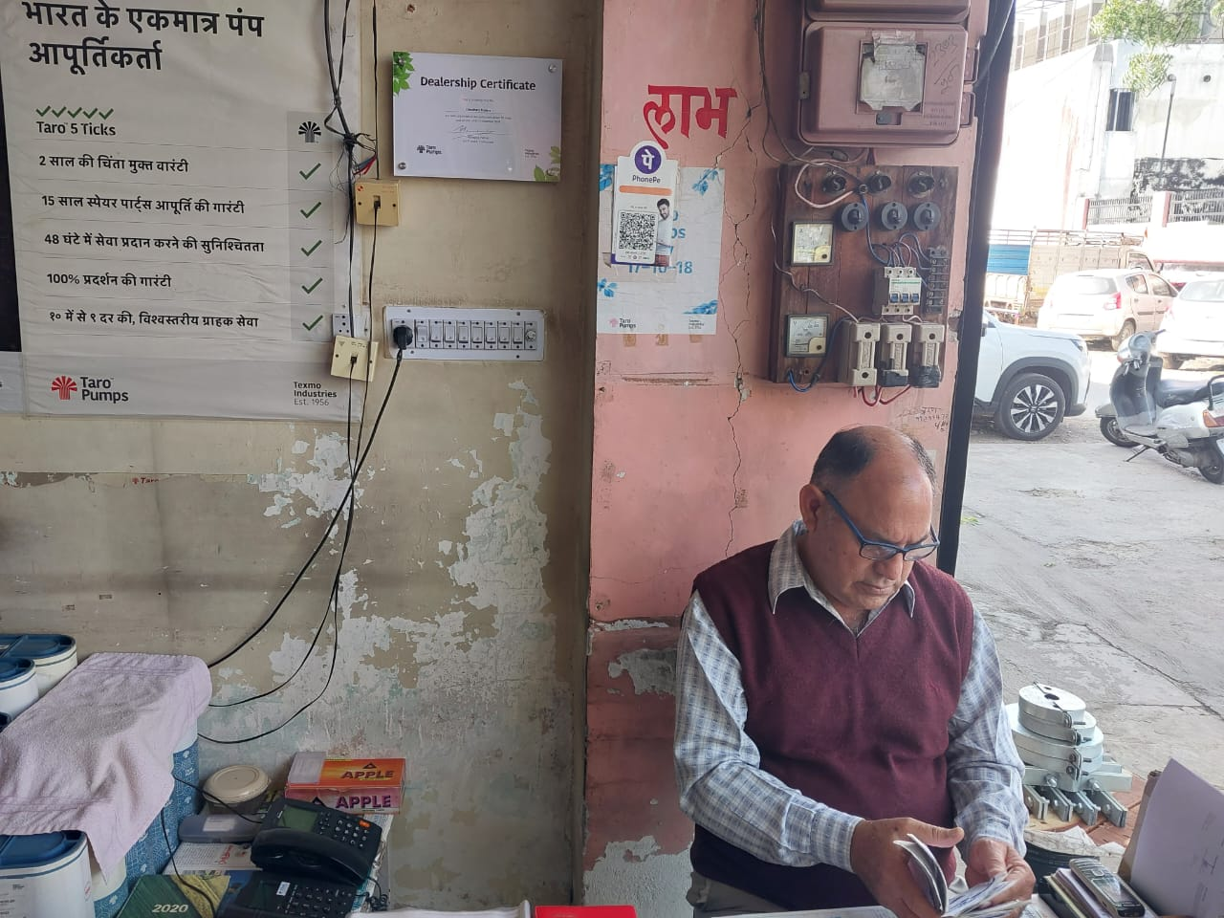

10. Were the sales staff wearing Taro Pumps uniform and were they neat and clean?

Ans. – 1/5 Dealer’s Sales staff did not wear taro pumps uniform and dealer also did not wear taro dealer uniform.

11. Were the staff clean? (Did any of them have offensive odour - paan, smoking drinking general hygiene)

Ans. Yes, 4/5

12. Were the staff polite, friendly and courteous towards customers?

Ans. - Yes, 4/5

13. At the time of audit, were there any dealer policies not being followed?

Ans. 4/5, No dealer did not violated any policies.

14.Has the dealership readily been able to describe any learnings and implementation of them during the quarter?

Ans.- 4/5 , Dealer’s two mechanics attended tct offline program.

15.Does the dealership have a TV running Taro Pumps digital content and was it functioning during the time of the audit?

Ans.- 1/5, There is no TV.

16.Does the dealership display Taro Pumps in-store advertising?

Ans. – 3/5, yes V4 in-store advertising is missing.

17. Has the dealer posted at least 10 pump installations with pictures of happy customers, within the last 3 months on their Facebook profile?

Ans. – 3/5 ,Dealer’s facebook page is active and dealer has posted post.

18.Any other observations to note?

Ans. –